Day 3 – What does the government buy?

We know the government buys everything. But what exactly does that mean?

In today’s lesson we will be discussing not only what they buy, but also how they buy it?

Even if you have seen similar videos before please watch today’s assignment, as it is specific to the upcoming homework and modules that you will be learning in Day # 4.

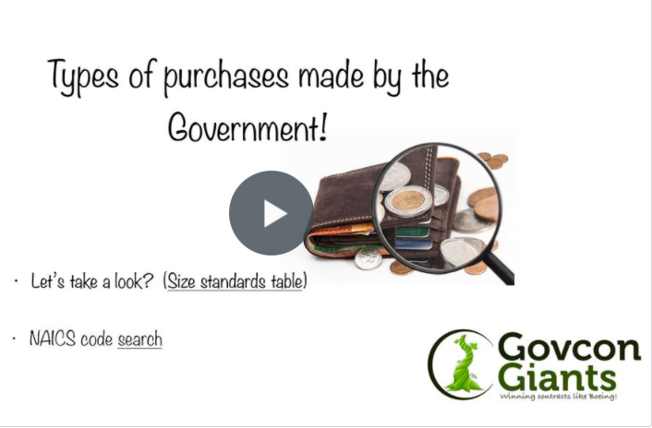

Complete Day 2 Training Now

I wish you much continued success,
Eric Coffie

